LAB # 15
OPERATORS IN MONGODB

Objectives :

• To understand and apply Comparison Operators in MongoDB queries.
To learn and use Logical Operators for complex query conditions.
To use Update Operators to modify document fields efficiently.

Lab Tasks :

1. Create a database named 'store' with a 'products' collection. Insert at least 10 product documents with fields: name, category, price, rating, tags (array), and inStock (boolean).

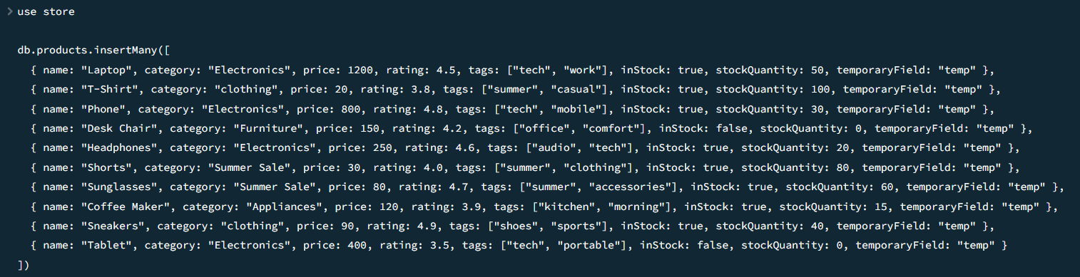
2. Use comparison operators to find: (a) products priced between 500 and 2000, (b) products with rating greater than or equal to 4, (c) products NOT in the 'clothing' category.

Source Code

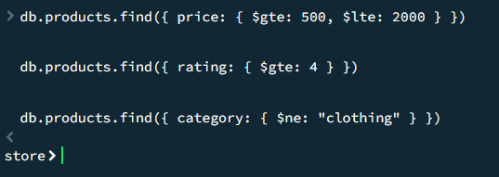

Source Code

3. Use $and to find products that are inStock: true AND have a rating above 3.5. Use $or to find products either under price 300 or with a rating above 4.5.

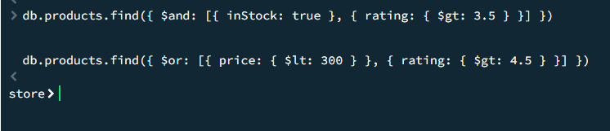

Source Code

4. dUse $set to update the price of a specific product. Use $inc to increase the stock quantity of all 'Electronics' products by 10.

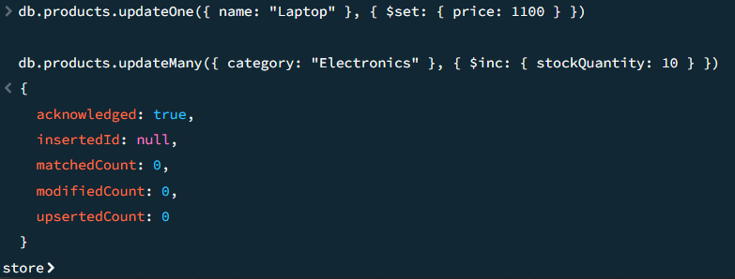

Source Code

5. Use $push to add a new tag to a product, then use $pull to remove all products with a rating less than 2 from a 'lowRated' array field.

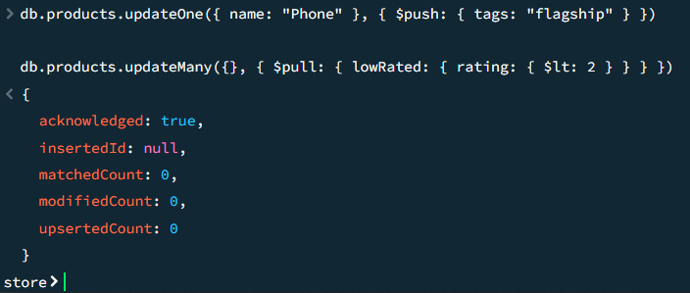

Source Code

6. Use $mul to apply a 15% discount to all products in the 'Summer Sale' category. Then use $unset to remove the 'temporaryField' from all documents.

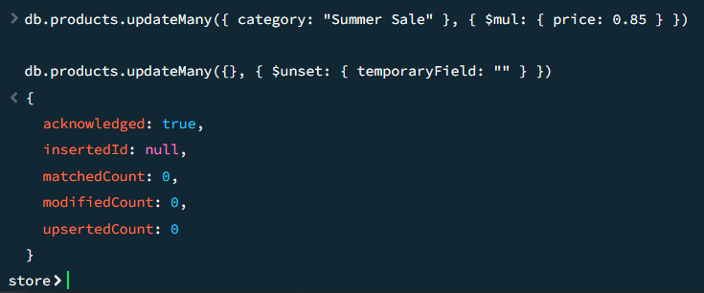

Reflection Questions:

1. What is the difference between $gt and $gte operators? Give an example of when you would use each.

The $gt operator strictly matches values greater than the specified number, while $gte matches values that are greater than or equal to the specified number. You would use $gt when setting an exclusive lower boundary (e.g., finding products strictly over $100 using price: { $gt: 100 }). You would use $gte for inclusive boundaries, such as checking if a user is legally an adult (e.g., age: { $gte: 18 }).

2. When would you use $or instead of $and, and what happens when you combine them?

You use $or when you want a document to be returned if it meets at least one of the specified conditions. You use $and when a document must meet all of the conditions to be returned. When combined, you can create complex, nested logical structures, such as ensuring a document meets a mandatory baseline condition while also satisfying at least one of several optional conditions (e.g., "Must be in stock AND (must be on sale OR must have a 5-star rating)").

3. What was the most challenging operator to understand, and how did you figure it out?

The $pull operator can be tricky to conceptualize when applying conditions to the elements being removed from an array. It requires understanding that the condition inside the $pull object acts as a mini-query against the elements of that specific array. Looking closely at syntax examples and testing how it targets nested fields or specific values within arrays makes the logic clearer.

